Product Information
Construct: | PIM1, (GST-full length)
Concentration: | 1.20 mg/ml
Species: | Human
Formulated In: | 40 mM Tris-HCl pH 8.0, 110 mM NaCl, 2.2 mM KCl, 0.04% Tween-20, 20% glycerol, 3 mM DTT, 2 mM glutathione
Expression System: | Sf9
Format: | Aqueous buffer solution
Stability: | At least 6 months at -80°C. Avoid freeze/thaw cycles.
Storage: | -80°C
Genbank Accession: | NM_002648
MW: | 62 kDa
Purity: | >90%
Specific Activity: | ≥150 pmol/min/µg
Assay Conditions: | 40 mM Tris-HCl pH 7.4, 20 mM MgCl2, 0.1 mg/mL BSA and 1 mM DTT using 0.2 mg/ml S6Ktide substrate and 20 μM ATP. Reaction was done at 30°C for 35 min. Amount of ATP transferred was calculated using Kinase-Glo reagent from Promega.
Applications: | Useful for the study of enzyme kinetics, screening inhibitors, and selectivity profiling.

Quality Control Data
4-20% SDS-Page Coomassie Staining | Specific Activity
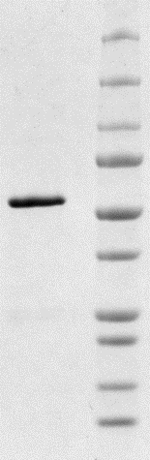  1 2  – 15 kDa  – 20 kDa  – 25 kDa  – 37 kDa  – 50 kDa  – 75 kDa  – 100 kDa  – 150 kDa  – 250 kDa  – 10 kDa | 